Encore Stage & Studio
Myths & Legends Fall 2016
10am-11am Saturdays, Nov.12-Dec.10
Thomas Jefferson Middle School

Participants: 8-15
Ages: 8-11 (Grades 4-5)

Unit Objectives: Students will discover and explore the three Actor’s Tools (Body, Voice, and Imagination), work together and build an ensemble, and use improvisation, devising, and rehearsal to explore Greek characters and myths.

WEEK 1 of 4: November 12

Objectives: 1. Students will be introduced, and become familiar, with the three Actor’s Tools (Body, Voice, and Imagination)
2. Students will explore characters from Greek Myths
3. Students will work in groups to create story-based tableaus

Materials: “Greek Characters Getting to Know You” cards
3 story excerpts from Greek Myths by Olivia E. Coolidge

Introduction (10 minutes)
- Introduce facilitator
- Name Activity Hi, My Name is….Pantomime
  - The group stands in a circle and take turns going around introducing themselves. Each person says “Hi, my name is______and I like to __(bike, swim, read, sing, play basketball, dance etc.)__” at which point they will act out or pantomime the activity that they enjoy doing. The group will then respond by waving, saying “ HI, _____” and repeating that person’s name and copying their activity pantomime. The facilitator should introduce themselves first to demonstrate.
- Brainstorm class ground rules that make class a safe space. Everyone agrees to the rules the group comes up with.
  - Respect and listen to whomever is talking
  - Respect other people’s personal space, belongings, and ideas
- Introduce the idea of the Actor’s Tools
  - The three Actor’s Tools (Body, Voice, and Imagination) are the three tools that actors have at their disposal no matter the situation or venue.
  - Acting is simply storytelling. Outside elements (costumes, sets, scripts, etc.) are excellent tools, but you can tell a story using only your Body, Voice, and Imagination.
  - Students should be given the opportunity to guess what the Actor’s Tools are, and encouraged when they give answers such as “costumes” or “sets” or “scripts.” Those are all definitely tools actors use, but what are three basic tools you can think of that actors have with them no matter where they go?
- Transition: How many of you have read Greek Myths before? Percy Jackson? In this class, we will be using our Bodies, Voices, and Imaginations to create our own stories using mythological characters!
Warm-Up (20 minutes)
- Ensemble Building Greek Characters Getting to Know You
  - Have students spread out around the room
  - Each student will receive either a rounded edge “character card” or a rectangular “definition card”. If all cards are not being used, make sure that each of the character cards being used has a corresponding definition card
  - Students will review the contents of their card, and then everyone will try to team up with the person who has their corresponding card. ex: “Hi, my name is Carol and I have Artemis and Apollo on my card. I think Artemis was the goddess of the hunt. What does your card say?”
  - When students find their matching pair (or their best guess at the match), they will introduce themselves. Then, each pair will have a chance to introduce their partner, and the pair will tell the group what was on their cards. The paired students will then strike a pose in the style of the characters described on their cards.
    - If cards do not correspond, the group will work together to re-match the people with corresponding cards.

- Body/Imagination Activity Frozen Picture Landscapes
  - Split the group evenly between audience members and actors. Audience members watch, while actors stand facing the group
  - The facilitator will give the actors onstage a location or situation and the actors will freeze into a statue pose that shows that location/situation
    - Audience participates with “3..2..1..Freeze!”
    - Locations: beach, Disney World, shopping mall, etc.
- Facilitator will redirect staging to demonstrate: levels, turning out to audience, easily held frozen poses, grouping characters with similar intentions, etc.
- Facilitator will then tap actors on the head to activate one line their character might say
- Groups switch; audience members become actors and actors become audience members
Read Myths in Groups (10-15 minutes)
- Facilitator will split the class into 2 or 3 groups. Each group will pick a different spot in the room
- Each group will receive a story excerpt from Greek Myths, and take turns reading it out loud

Myth Frozen Pictures (15 minutes)
- Groups will create three tableaus: one for their story’s beginning, middle, and end
- Groups will each get a chance to share their story tableaus with the class
  - Each group will give their story title, and tell the audience which character they are portraying
  - Audience will guess what is happening in each scene

POWs and WOWs (5 minutes)
- The group sits in a circle for a closing. Everyone has a chance to share their least favorite (POW) and favorite (WOW) part of class.
- First, everyone takes turns around the circle sharing their least favorite part of class. After each person shares, the group punches their fists into the air shouting “POW!” to send off each individual negative experience.
  - If they do not have a POW, students can say “Pass”
- Second, the class takes turns around the circle sharing their favorite part of class. After each person shares, everyone holds up both their hands with three fingers, each hand making a “W” shape. Placing these “W”s on either side of the face (in which the mouth is the “O” of “wow”), everyone exclaims “WOW!” to celebrate each individual positive experience.

**You won’t see me next week, but I will see you again December 3**

WEEK 2 of 4: November 19 (LESSON FOR A SUBSTITUTE TEACHER)

Objectives: 1. Students will explore the Three Actor’s Tools (Body, Voice, and Imagination)
2. Students will work in groups to outline the details of their devised myth
3. Students will create character masks to be used in their final sharing

Materials: Myths Planning Sheets
Myths Planning Sheet example
Character Mask example
God/Goddess Symbol List
Pencils
Colored Pencils/Crayons
Stapler
Paper plates
Paper head bands

Introduction (2 minutes)
- Name review: Group sits in a circle. Everyone shares their name and favorite book (or another fun fact)
- Classroom rule reminders: Respect others, respect space, listen to whomever is speaking
- Body, Voice, Imagination Review
  - What are the three Actor’s Tools again? Great! Let’s get warmed up.
Warm-Up (10 minutes)
- Body/Voice: Energy, Energy!
  - Group stands in a circle. The facilitator will call out a phrase that verbally isolates different parts of the body, while demonstrating a corresponding movement. Students will echo the phrase and copy the movement
    - ex. Facilitator will call out “Energy, energy in my hands!” while demonstrating the ASL sign for applause/clapping hands in rhythm/doing jazz hands etc. The students will then echo back “Energy, energy in my hands!” while copying the facilitator’s movement
  - Each isolation will be repeated twice for rhythm.
    - Energy, energy in my hands! (Energy, energy in my hands!)
Energy, energy in my hands! (Energy, energy in my hands!)
While stomping feet:
Energy, Energy in my feet! (Energy, energy in my feet!)
Energy, Energy in my feet! (Energy, energy in my feet!)

  - After isolating several body parts, facilitator will add in a few silly echoes (these should also be repeated twice):
    - ex. While doing the Robot: Energy, Energy in my Robot!
    - ex. While doing a jig: Energy, Energy in my leprechaun!

  - Going around the circle, each student will get a chance to share their own Energy, Energy with a movement, or repeat one they have already seen. The group will echo back each time.
Myth Devising Outline (25 minutes)
- Split class into two or three groups (Teaching Artist will provide group list for Substitute ahead of time)
  - Have the group quickly identity their group “scribe” to write down ideas
- Each group will receive a Myths Planning Sheet and pencils to outline their ideas
  - Each group member picks which mythological character they want to play. This could be a god, goddess, hero, villain, monster, etc.
    - If they have trouble remembering the name of a god or goddess, they may refer to the God/Goddess Symbol list
    - It is ok if two group members want to play the same character. Those two actors will find a way to work together to demonstrate that character.
- Groups work together to come up with an outline of their new myth.
- Groups will finish the activity by drawing stick figure comics to plan for three tableaus for their story. The groups will then get on their feet and practice the tableaus they have created.
  - All group members must be used in each frozen picture (they do not have to be a character in every picture—they might decide to be a tree or a building)
Character Masks (20 minutes)
- Students will each use art supplies to create a mask that represents the character they chose for their group myth
  - Students should take their time. Their mask will be their “costume piece” for the final Sharing.
  - After students have decorated their headband and paper plate, the Facilitator will assist in measuring the headband to each individual’s head size, and stapling the head band into place
    - Make sure the flat side of the staple is touching the student’s head, and the sharp side of the staple is on the outside of the head band
- Students may refer to the God/Goddess Symbol List to help inspire their mask design
- Facilitator will collect finished masks and hold onto them until the Sharing
POWs and WOWs (5 minutes)
- The group sits in a circle for a closing. Everyone has a chance to share their least favorite (POW) and favorite (WOW) part of class.
- First, everyone take turns around the circle sharing their least favorite part of class. After each person shares, the group punches their fists into the air shouting “POW!” to send off each individual negative experience.
  - If they do not have a POW, students can say “Pass”
- Second, the class takes turns around the circle sharing their favorite part of class. After each person shares, everyone holds up both their hands with three fingers, each hand making a “W” shape. Placing these “W”s on either side of the face (in which the mouth is the “O” of “wow”), everyone exclaims “WOW!” to celebrate each individual positive experience.

**No Class November 26**
WEEK 3 of 4: December 3

Objectives: 1. Students will explore the Three Actor’s Tools (Body, Voice, and Imagination)
2. Students will work in groups to finalize the details of their devised myths
3. Students will work in groups to rehearse and share their devised myths

Materials: Myths Planning Sheets
Pencils

Introduction
- Classroom rule reminders: Respect others, respect space, listen to whomever is speaking
- Body, Voice, Imagination Review
Warm-Up (5-10 minutes)
- Voice/Body Activity: Princess Pat
  - Facilitator calls out each line of the song with big dance moves/fun gestures and students repeat words and gestures
    - The Princess Pat (the Princess Pat)
Lived in a tree (lived in a tree)
She sailed across (she sailed across)
The Seven Seas (the Seven Seas)
She sailed across (she sailed across)
The channel too (the channel too)
And she took with her (and she took with her)
A rig-a-bamboo (A rig-a-bamboo)

Chorus: A rig-a-bamboo (a rig-a-bamboo)
Now what is that (now what is that)
It’s something made (it’s something made)
By the Princess Pat (by the Princess Pat)
It’s red and gold (it’s red and gold)
And purple too (and purple too)
That’s why it’s called (that’s why it’s called)
A rig-a-bamboo (a rig-a-bamboo)

Now the Captain Jack (now the Captain Jack)
Had a mighty fine crew (had a mighty fine crew)
He sailed across (he sailed across)
The channel too (the channel too)
But his ship sank (but his ship sank)
And yours will too (and yours will too)
If you don’t take (if you don’t take)
A rig-a-bamboo (a rig-a-bamboo)

Chorus Repeats
Finalize Myth Details (15 minutes)
- Students will get into their myth groups and decide how they want to present their myth. Facilitator will hand out each group’s Myths Planning sheet to help groups review.
  - Students will use their Beginning, Middle, End tableaus as a structure for their story.
  - To tell their myths, students might decide to act out their story with lines, have a narrator, incorporate tableaus into their action, write a song/poem for a section of their story, etc.
Group Rehearsal (15 minutes)
- Groups will have a chance to rehearse their ideas for their myth presentation
- Facilitator will check in with each group to help solve issues, and to remind actors about spacing/volume/turning to audience etc.
Share Myths with Redirects (15 minutes)
- Each group will get a chance to share their myth with the class. The audience will help start the scene by saying “3..2..1..ACTION!”
- Facilitator may change placements (paying attention to actors facing towards the audience and using the performance space to move)
  - Facilitator will call the actors to freeze and then give them a redirect (ex. turn your body out to the audience, project your voice, etc.)
POWs and WOWs (5 minutes)
**Sharing Day Next Class**
WEEK 4 of 4: December 10 (SHARING DAY)

Objectives: 1. Students will practice their devised myths for their sharing
2. Students will share their devised myths with an audience

Materials: Character Masks
Myths Planning Sheet
Introduction
- Go over Sharing Order
- Body, Voice, Imagination review
Warm-Up (5 minutes)
- Body/Voice: Oo I Feel So Good
  - Group chants together and moves in rhythm to the chant
    - Oo! I feel so good
Like I knew I would
Oo I feel so good!
- Facilitator calls out different parts of the body to isolate movement while chant repeats
  - In our shoulders/heads/fingers/knees/elbows/noses/feet now!
  - After several body isolations, transition to lowering volume of chant and crouching closer and closer to the ground (Bring it down now!) until everyone is lying on their stomachs on the floor, close to inaudible. Then:
  - Transition swiftly to loud volume and full body dancing (Bring it up, bring it up, bring it up!)
Groups Rehearse (10 minutes)
- Students will get into their groups to review and rehearse their myth
  - Facilitator will pass out Myths Planning Sheets to each group
Share Myths with Class (15-20 minutes)
- Each group will get a chance to share their myth with the class. The audience will help start the scene by saying “3..2..1..ACTION!”
- Facilitator may change placements (paying attention to actors facing towards the audience and using the performance space to move)
  - Facilitator might call the actors to freeze and then give them a redirect (ex. turn your body out to the audience, project your voice, etc.)
  - Sharing (20-30 minutes)
Parents arrive around 10:30am to watch
- Students will wear their character masks to perform **If your students enjoyed this class, check out Encore’s website at encorestageva.org to learn about upcoming classes and auditions! **
*Artemis
@Apollo
*Zeus
@Hera

*Aphrodite
@Ares
*Poseidon
@Hades

*Hermes
@Athena
*Demeter
@Dionysus

*Heracles
@Perseus
●Theseus
*Andromeda
@Ariadne

*Goddess of the moon and the hunt
@God of the sun, poetry, and music
Hint: These two characters are twins
*God of messengers and thieves
@Goddess of wisdom, war, and arts/crafts
Hint: The symbols of these characters are:
*winged sandals @owl
*Goddess of love and beauty
@God of war
Hint: These two characters are secretly dating
*God of the sea
@God of the underworld
Hint: These two characters are Zeus’s brothers
*King of the Gods, and of the sky
@Queen of the Gods, and of marriage/home
Hint: These two characters are married
*Goddess of the harvest
@God of the grape harvest, wine, and theatre
Hint: * Has a daughter named Persephone who is the wife of Hades.
@ symbol is the ivy vine

* Hero with amazing strength who completed 12 labors (There’s a Disney movie based on the myths about him)
@Hero who defeated the monster Medusa (Percy Jackson is named after him)
●Hero who defeated the Minotaur in the Labyrinth (He had help from Ariadne, who gave him a magical ball of string to guide him through the impossible maze)

*Daughter of King Cepheus and Queen Cassiopeia (she was rescued by Perseus and then married him)
@Daughter of King Minos who helps Theseus solve the impossible Labyrinth (She gives Theseus a magical ball of string to help guide him. She eventually marries Dionysus—god of wine)

SYMBOLS OF THE GODS
Name | Specialty | Symbols | Examples
Zeus | King of Gods, god of the sky | Lightning bolt and eagle | 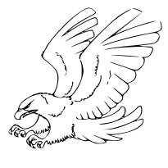
Hera | Queen of Gods, goddess of marriage | Peacock | 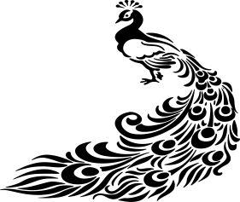
Hades | god of the underworld | Three headed dog and keys | 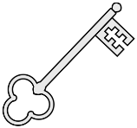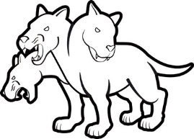
Poseidon | god of the sea | Trident | 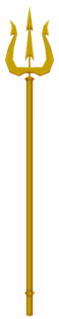
Aphrodite | goddess of love and beauty | Roses, dove, and scalloped shell | 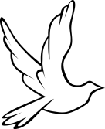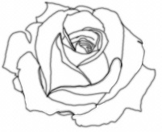
Apollo | god of the sun, poetry, and music | Laurel wreath and lyre | 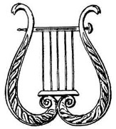
Artemis | goddess of the moon and the hunt | Silver bow and arrow and wild animals | 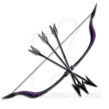
Demeter | goddess of the harvest | Wheat stalk and cornucopia | 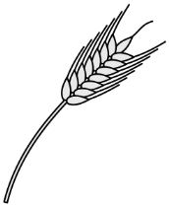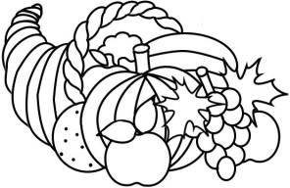
Ares | god of war | Spear, vultures, and poisonous snakes | 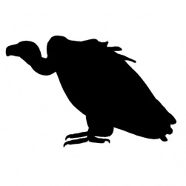
Dionysus | god of wine and theatre | Grape vine and ivy crown | 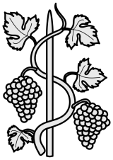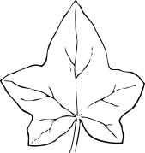
Hermes | god of messengers and thieves | Winged sandals and hat, caduceus | 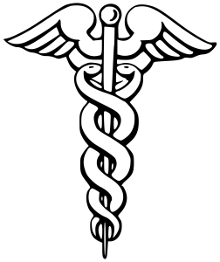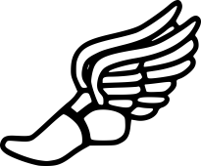
Athena | goddess of wisdom, battle strategy, and arts and crafts | Olive branch and owl | 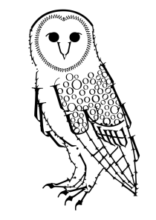

Plan Your Myth!
- Choose your mythological character. You may pick a god, goddess, hero, villain, monster, or another character from Greek myth.
Name of Group Member | Mythological Character You Want to Play
- Greek myths were usually created to do the following things:
  - Explain natural events in the world (ex. It’s thundering outside so Zeus must be angry!)
  - Tell adventure stories of heroes on a quest (ex. Perseus slaying Medusa, and then using her head to save Princess Andromeda)
Who are your heroes? Will your myth explain a natural event? If so, what natural event? Will your myth be about a quest? If so, what is the quest?

- In your myth, what is the major problem that needs to be solved? Who are your villains?

- List what happens in the beginning, middle, and end of your story:
Beginning | Middle | End
- On the back of this paper, draw three stick figure comics to plan for three tableaus to show your beginning, middle, and end. Then, get on your feet and practice them! Make sure to use all group members in each tableau.

